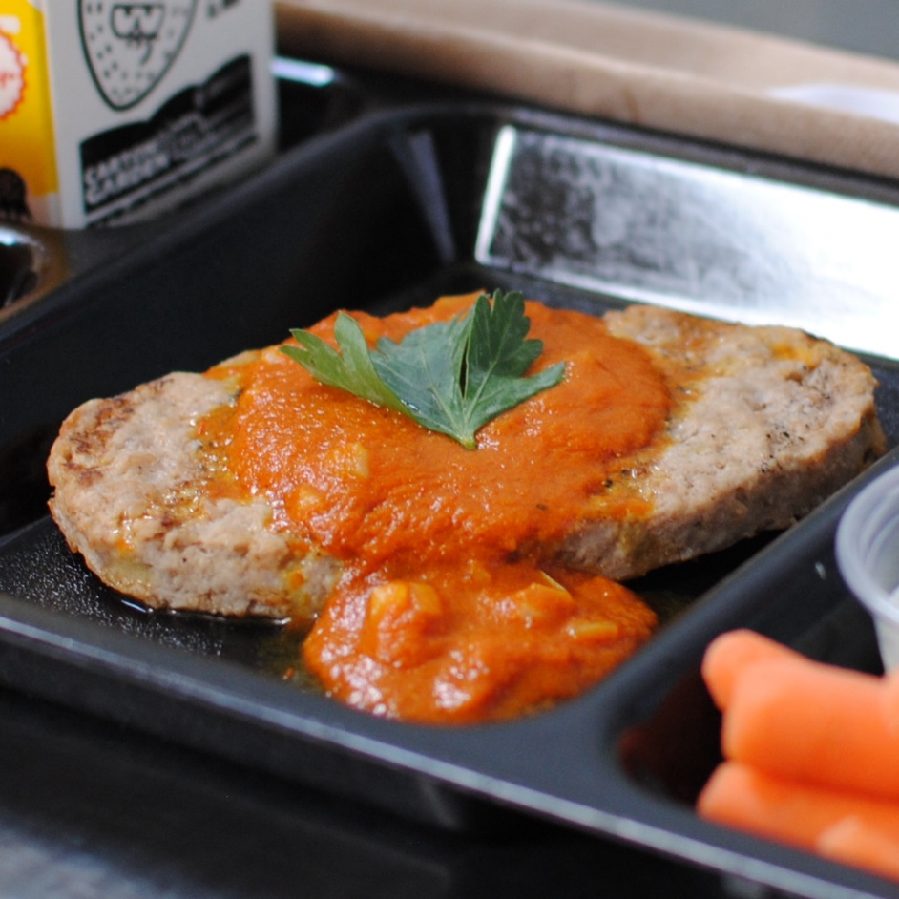

ZESTY BEEF STEAK
© Menu Freedom
INSERT DAY, DATE

