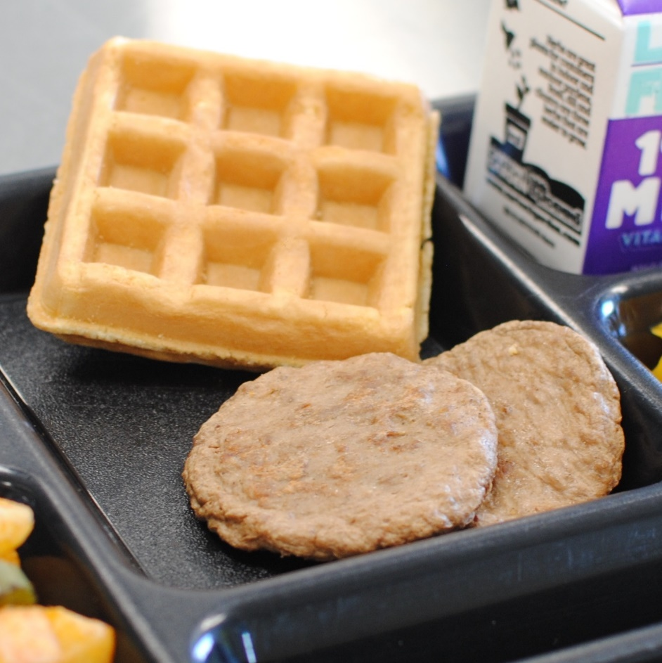­­­­­

**WAFFLE &**

**BREAKFAST SAUSAGE**

© Menu Freedom

**INSERT DAY, DATE**