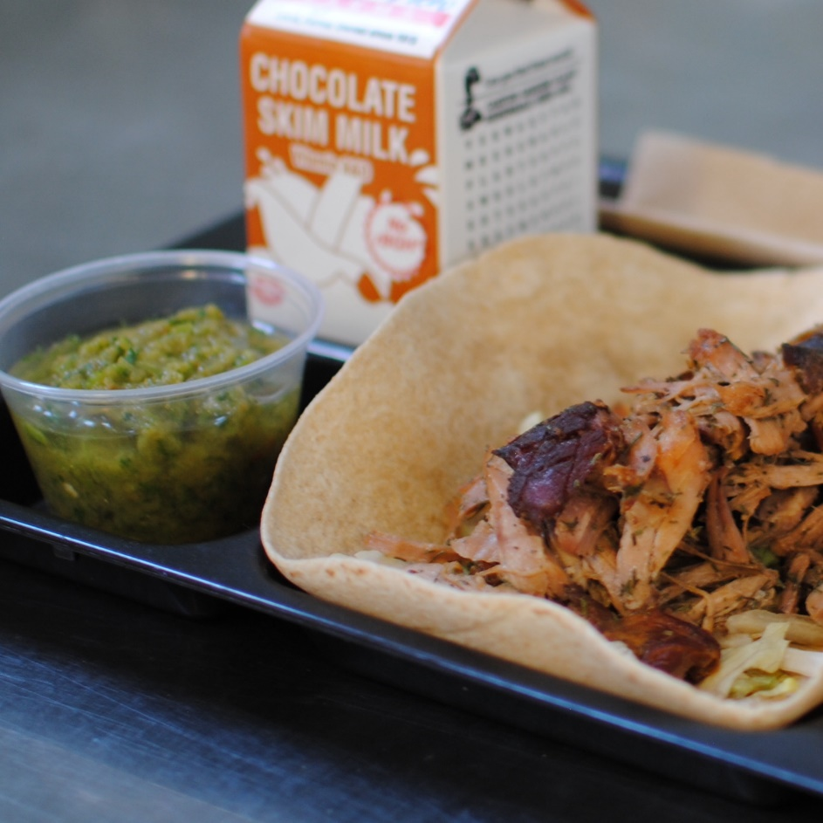­­­­­

**VERDE PORK TACO**

© Menu Freedom

**INSERT DAY, DATE**