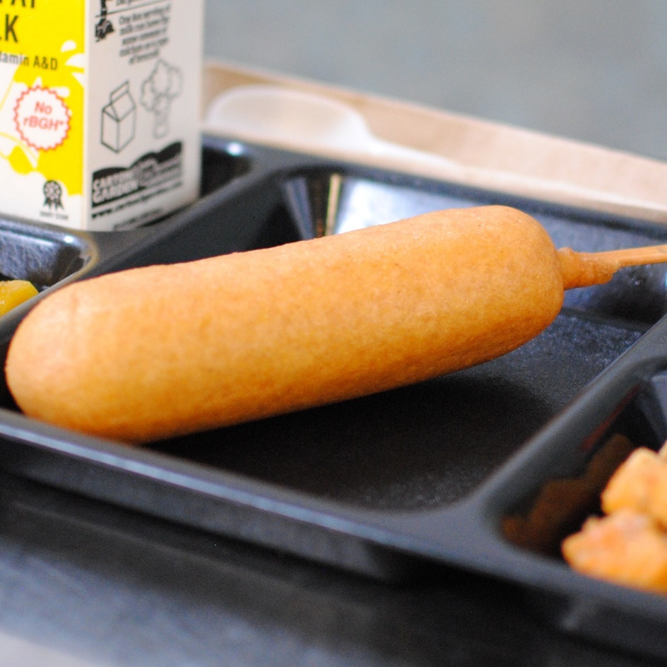­­­­­

**TURKEY SAUSAGE PANCAKE ON A STICK**

© Menu Freedom

**INSERT DAY, DATE**