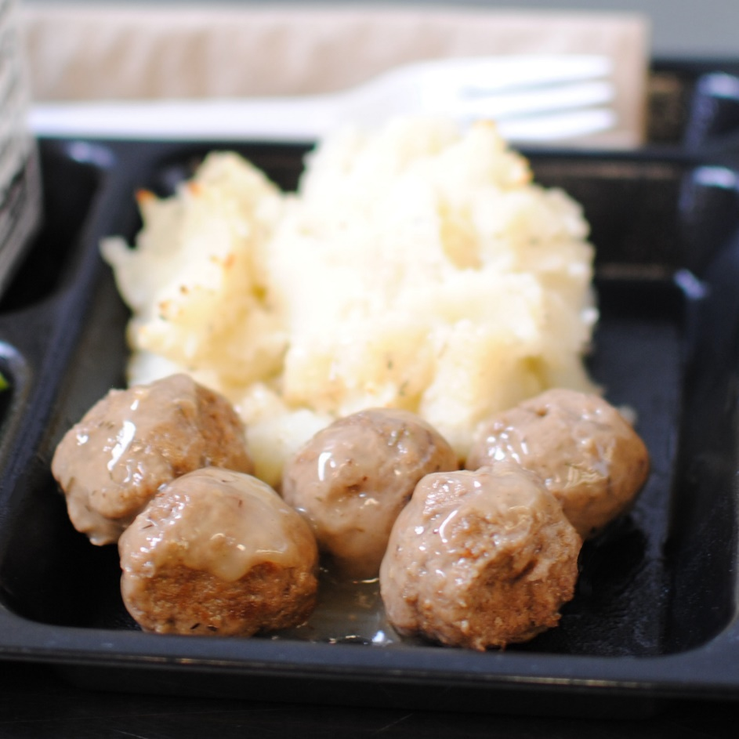­­­­­

**TURKEY MEATBALLS**

**W/ GRAVY**

© Menu Freedom

**INSERT DAY, DATE**