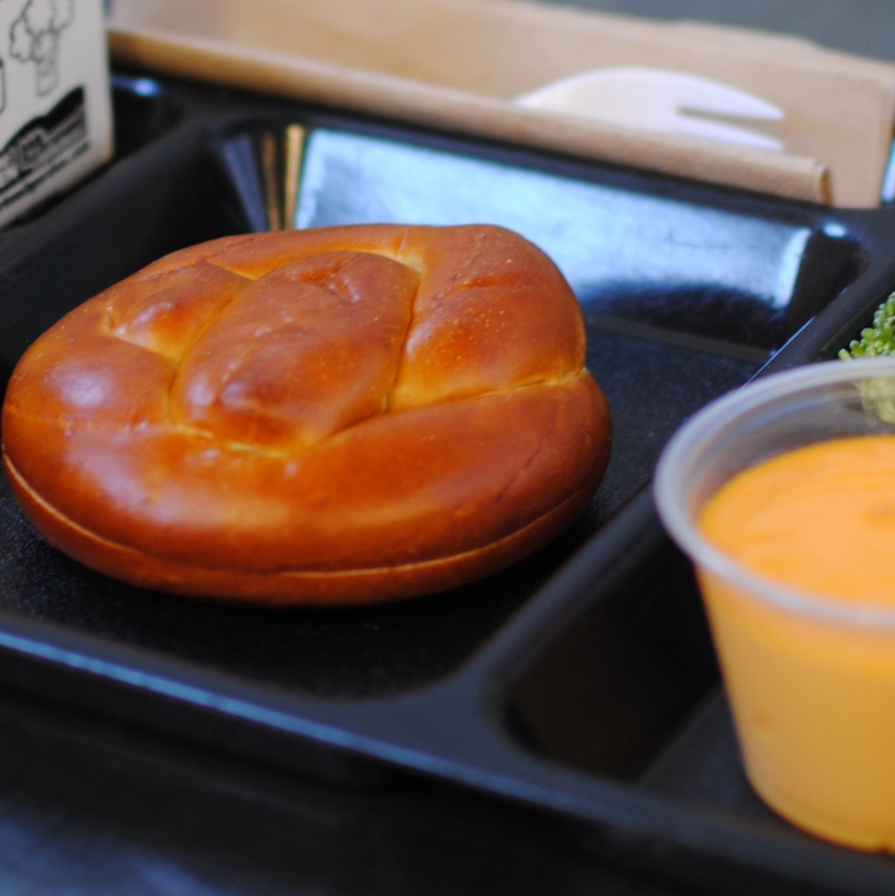­­­­­

**SOFT PRETZEL W/**

**CHEESE**

© Menu Freedom

**INSERT DAY, DATE**