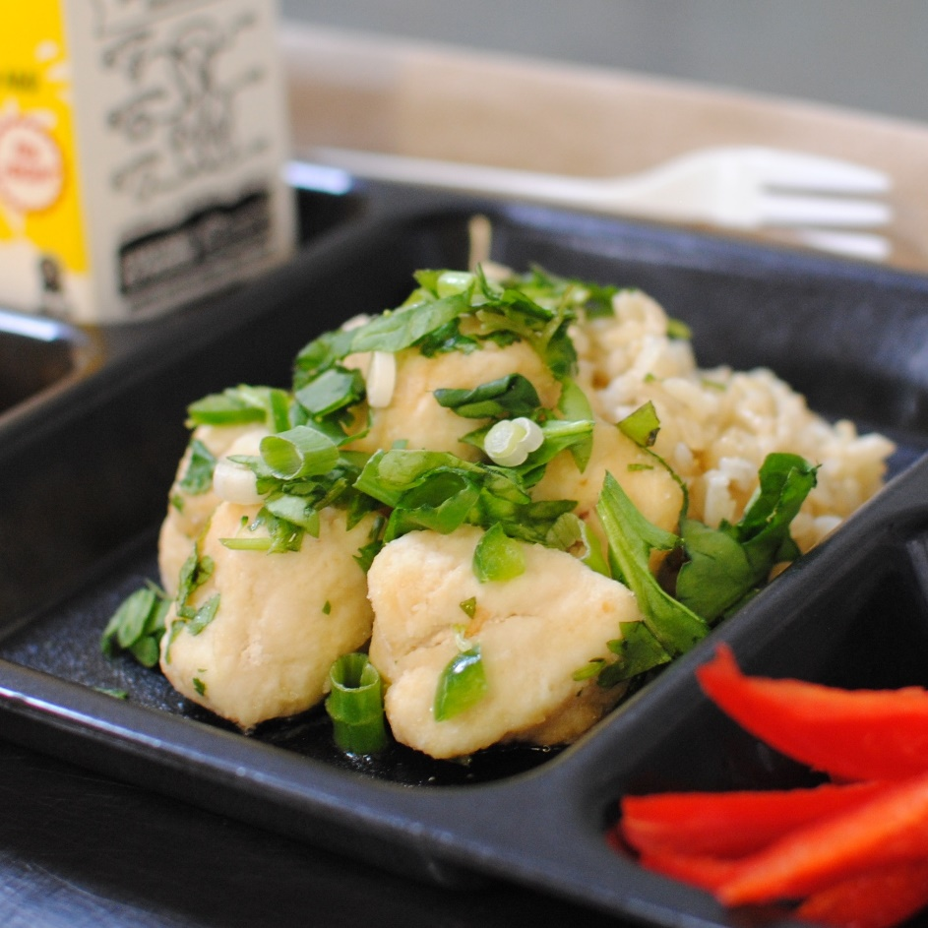­­­­­

**POLLO VERDE**

© Menu Freedom

**INSERT DAY, DATE**