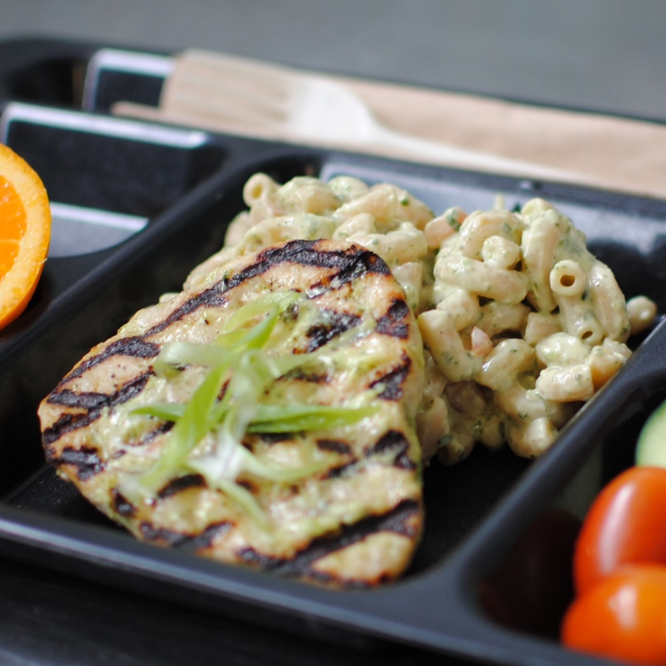­­­­­

**PESTO CHICKEN PASTA**

© Menu Freedom

**INSERT DAY, DATE**