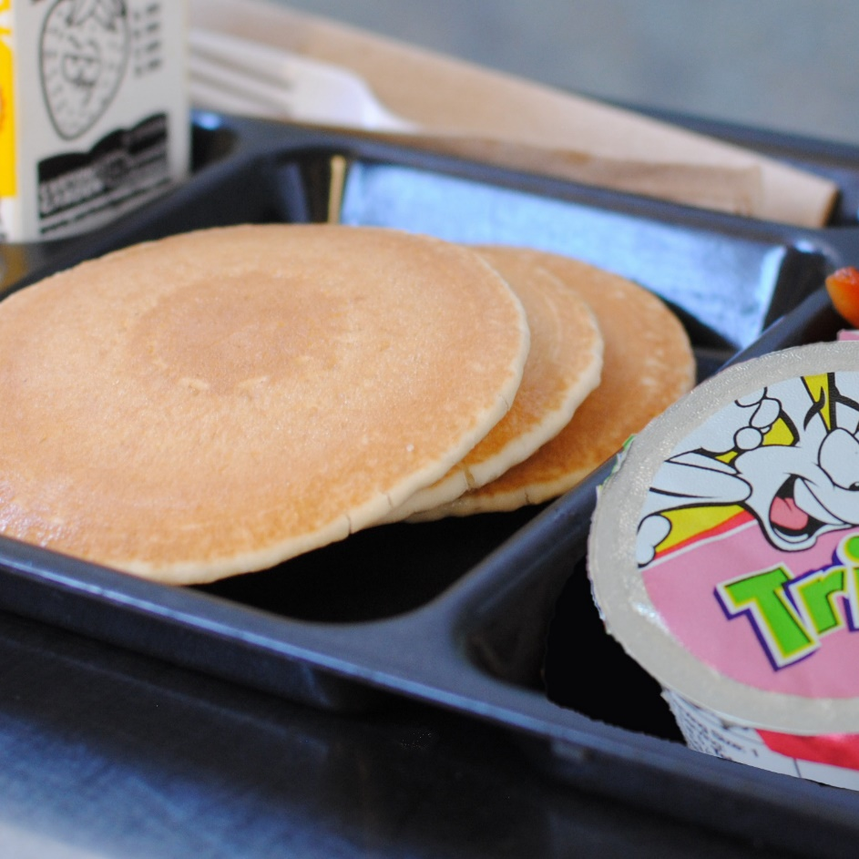­­­­­

**PANCAKES W/**

**YOGURT**

© Menu Freedom

**INSERT DAY, DATE**