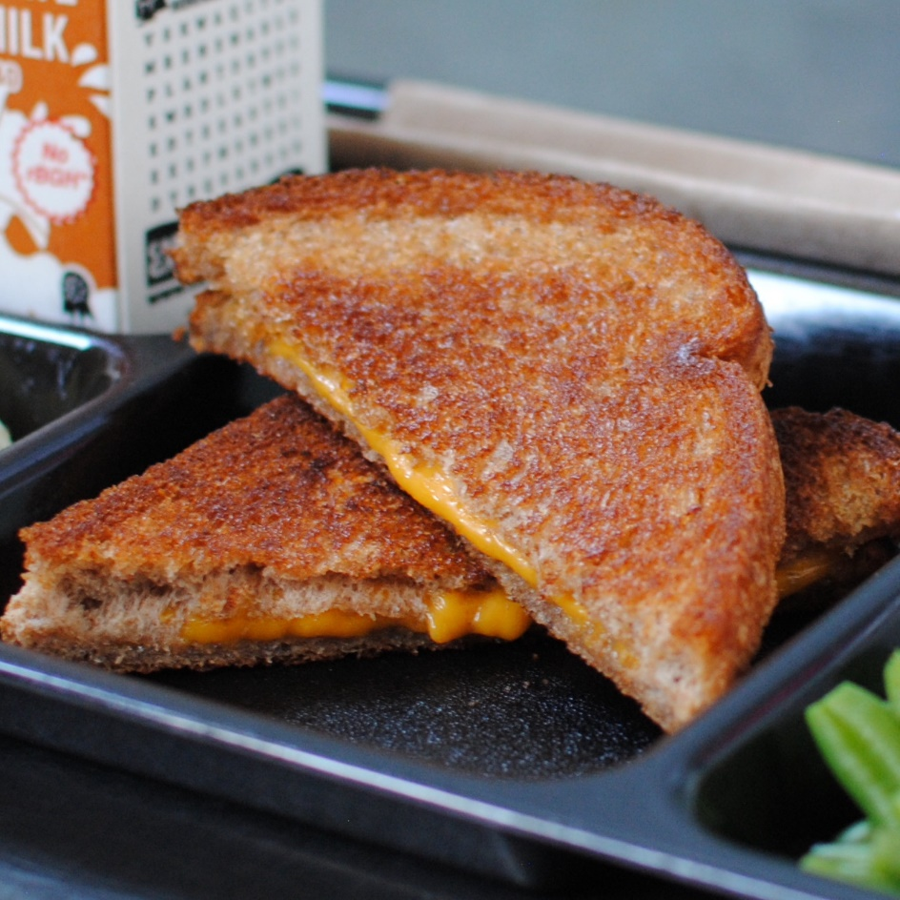­­­­­

**GRILLED CHEESE & TOMATO SOUP**

© Menu Freedom

**INSERT DAY, DATE**