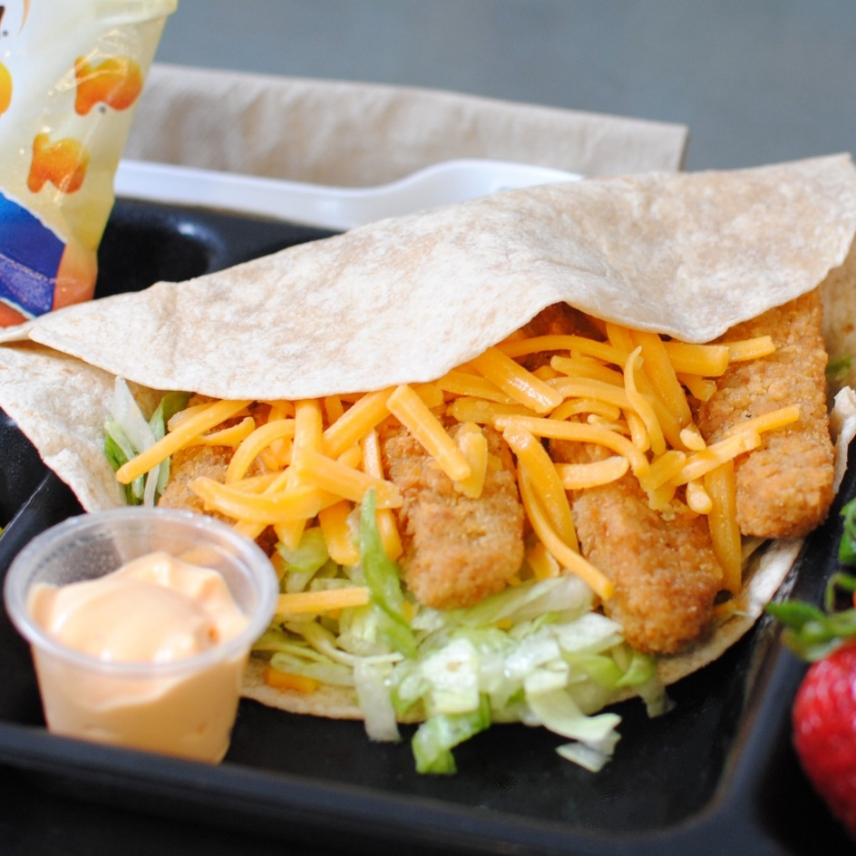­­­­­

**CRUNCHY CHICKEN TENDER WRAP**

© Menu Freedom

**INSERT DAY, DATE**