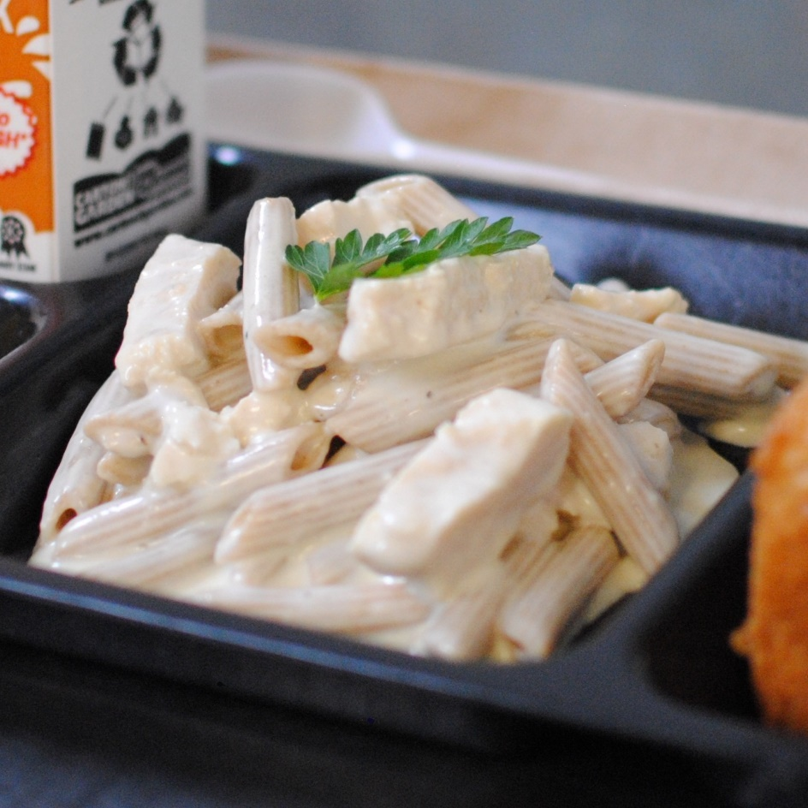­­­­­

**CHICKEN PENNE ALFREDO**

© Menu Freedom

**INSERT DAY, DATE**