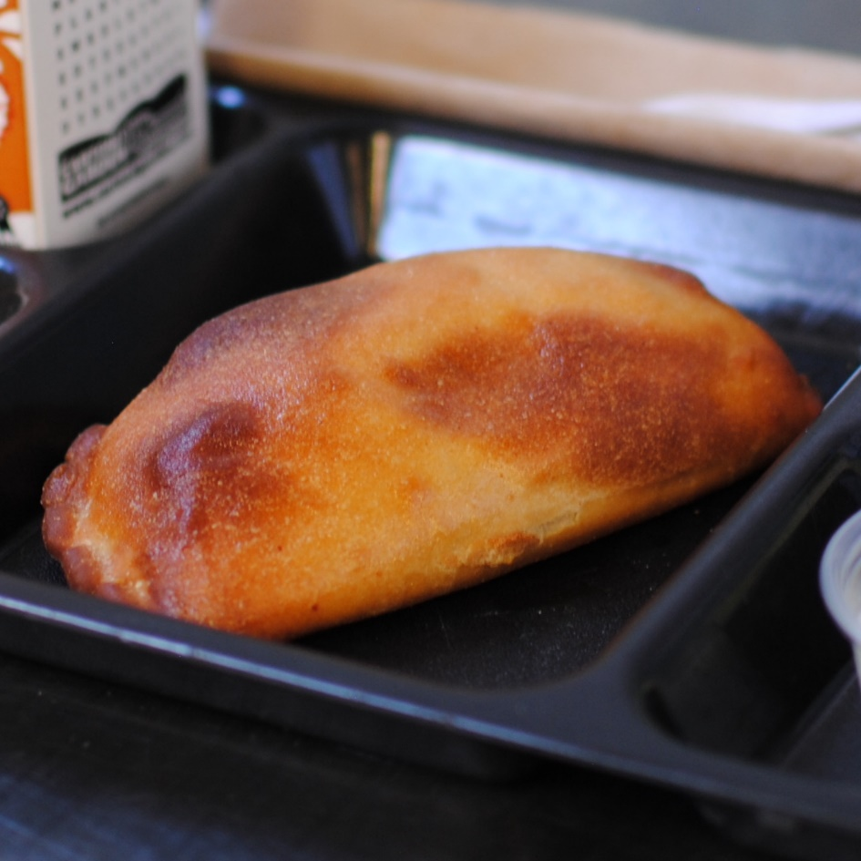

CHEESE CALZONE
© Menu Freedom
INSERT DAY, DATE

