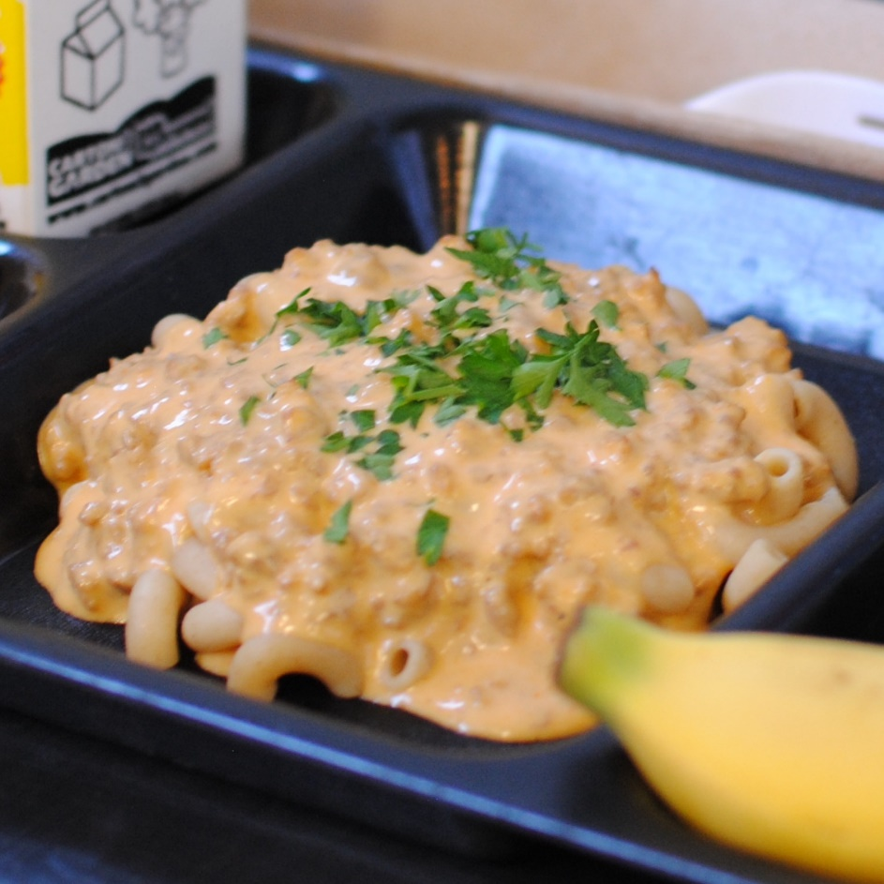­­­­­

**BEEFY QUESO**

**PASTA BAKE**

© Menu Freedom

**INSERT DAY, DATE**