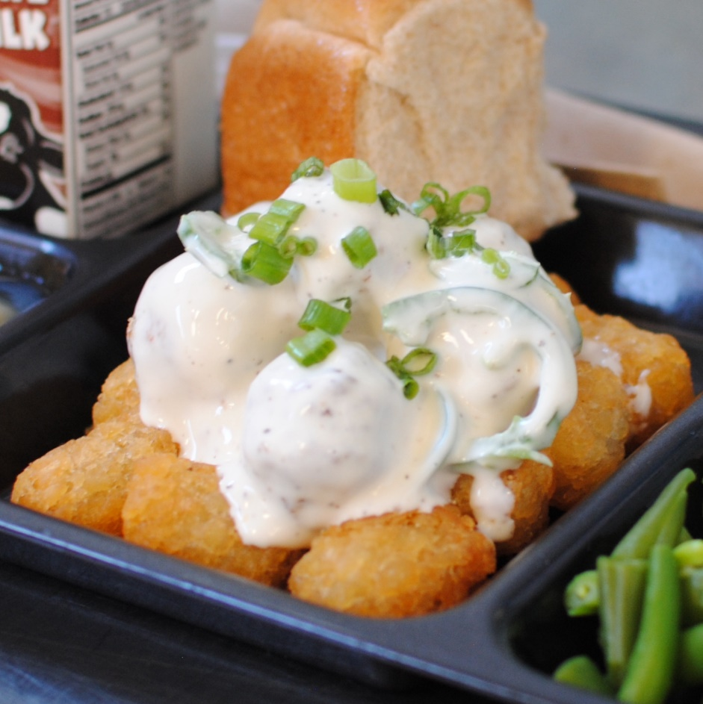­­­­­

**BEEF TATOR TOT NACHOS**

© Menu Freedom

**INSERT DAY, DATE**