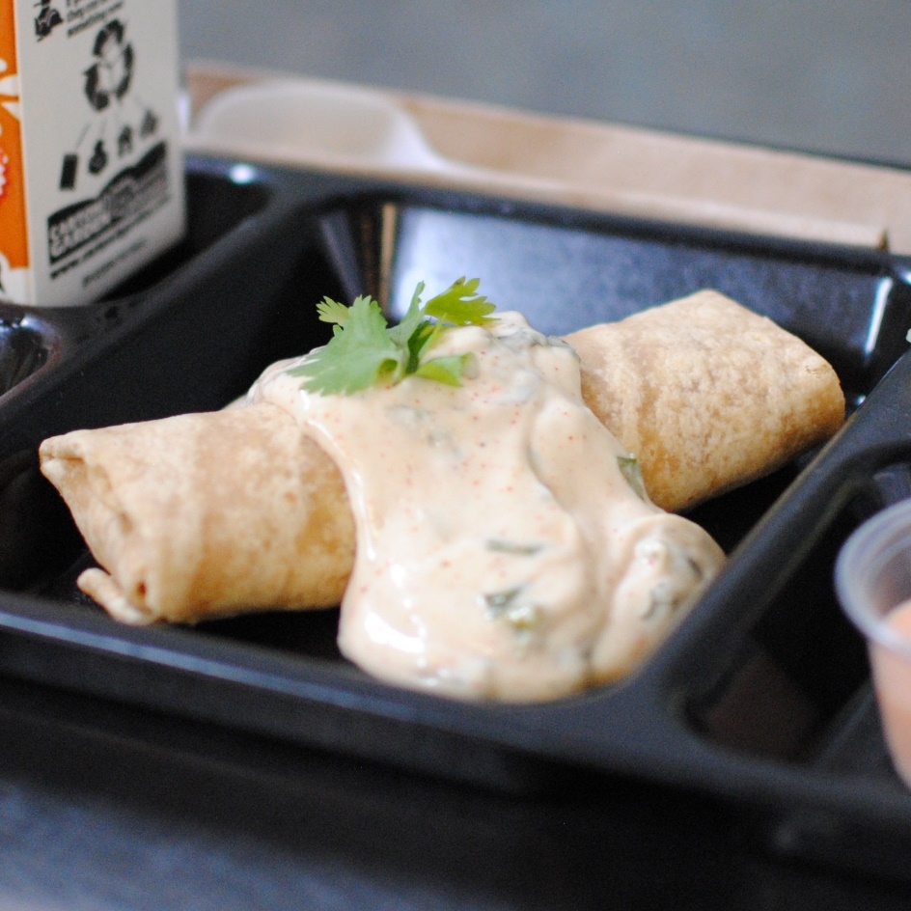­­­­­

**BEAN & CHEESE BURRITO**

© Menu Freedom

**INSERT DAY, DATE**