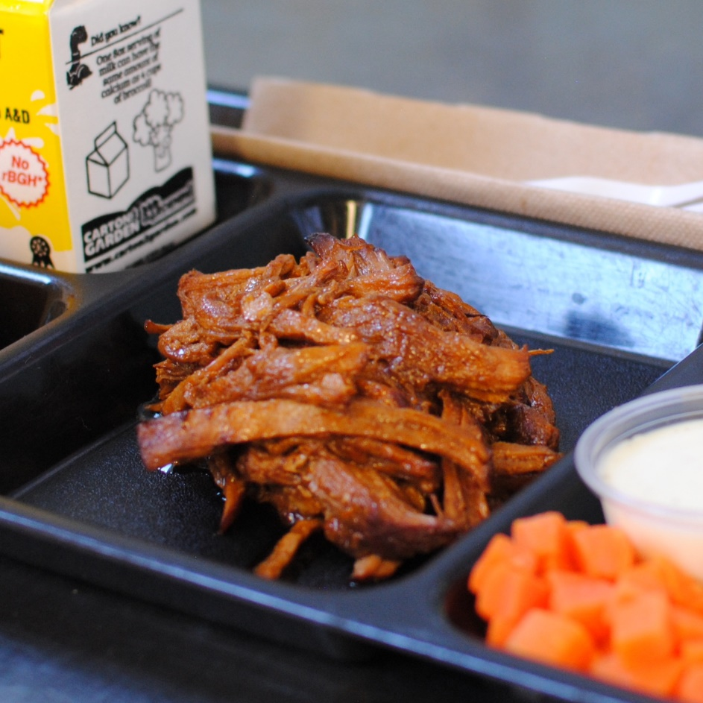­­­­­

**BBQ BAKED PORK**

© Menu Freedom

**INSERT DAY, DATE**