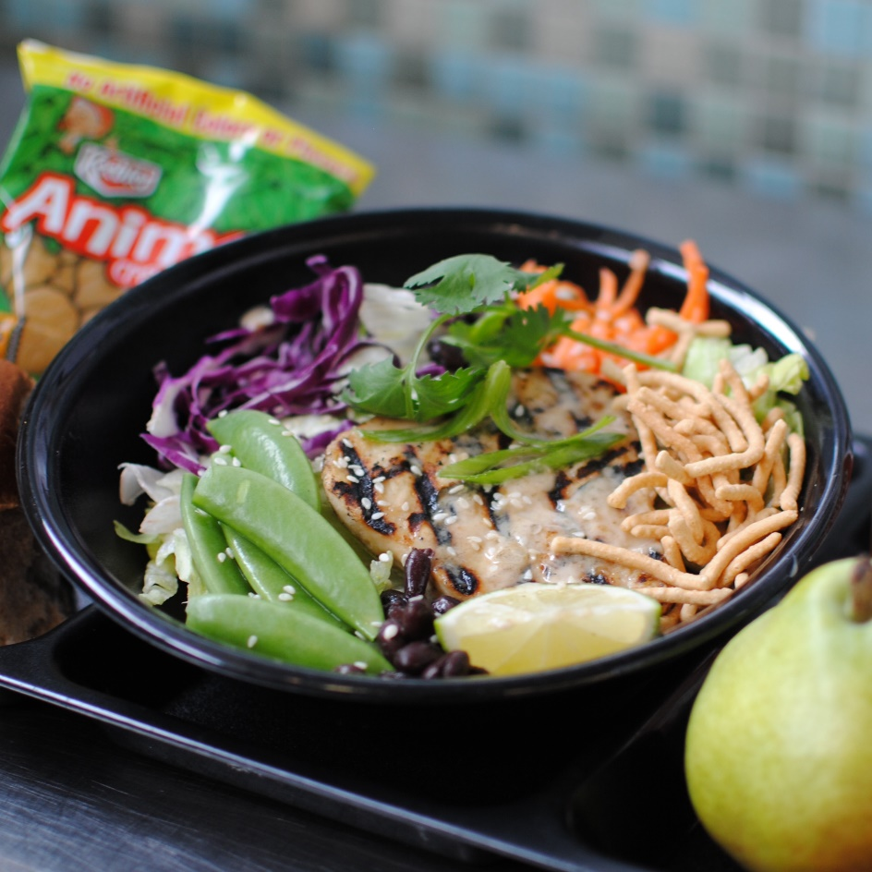­­­­­

© Menu Freedom

**INSERT DAY, DATE**

**ASIAN CHICKEN BOWL**